Meet the Teacher

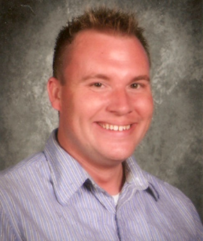
Hi! My name is Mr. Trammelle and I am going to be your third grade teacher! This is my twelfth year teaching in the county but my third year teaching third grade at Pangborn Elementary School. I love the exploring, learning, and fun we get to have.
I have a Master’s Degree in Reading from Frostburg State University and I love to teach reading! I could teach it all day! I enjoy how stories let you become someone else for a moment. I can’t wait to help you become an even better reader. I hope to introduce you to many new ways of learning Reading, Writing, Math, Science, and Social Studies using technology; another passion of mine.
I grew up in the area Cascade, MD and graduated from Smithsburg High school. I love to visit my parents often and I have a younger brother Joshua who lives in Chambersburg, PA.
This summer I started the process of building a townhouse. I can’t wait for it to be finished and I get to move in and make it my own.
I’m looking forward to spending this year growing and learning with you!
My Favorites
Food: Pizza  Movie: Pitch Perfect  Book: Harry Potter Series  Color: Green  Season: Spring  Sports Teams: Football – Steelers  Baseball - Orioles  Fast Food: McDonalds  Restaurant: Chipotle  Animal: Gorilla  Hobby: Acting/Singing | 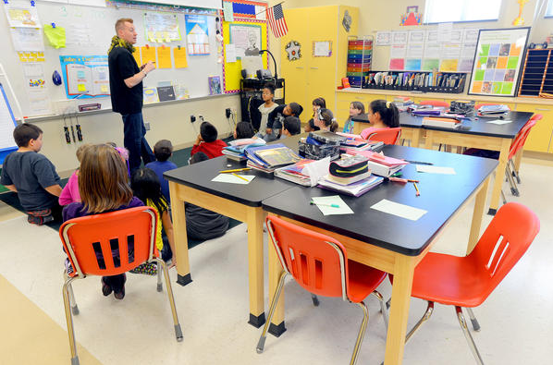

www.mrtrammelle.weebly.com
Email – trammjer@wcps.k12.md.us

